DBMS

**EXERCISE 1:**

**DATABASE:**

DBMS or Database Management System is a software application used to access, create, and manage databases. With the help of DBMS, you can easily create, retrieve and update data in databases. A DBMS consists of a group of commands to manipulate the database and acts as an interface between the end-users and the database.

**SQL:**

SQL (Structured Query Language) is a standardized query language used by relational database management systems (RDBMSs). It provides a consistent, English keyword-oriented set of facilities for query, data definition, data manipulation, and data control. SQL statements include data manipulation language statements such as SELECT, INSERT, UPDATE, and DELETE, data definition language statements such as CREATE and DROP statements for tables and indexes, and statements that control data consistency and grant and revoke authority. SQL statements are called "dynamic" when they are not completely specified until the program is executed.

**DDL:**

Data Definition Language (DDL) is a computer language used to create and modify the structure of database objects such as tables, indices, views, schemas, and users in a database.

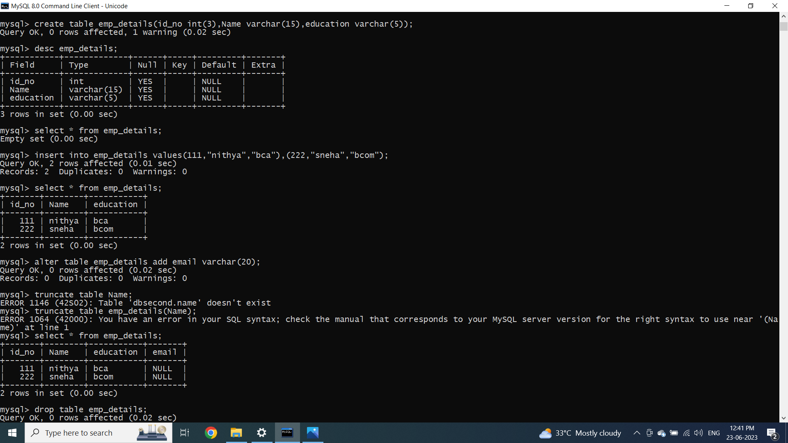

EXERCISE 2:

AGGREGATION FUNCTIONS

Enter password: *********

Welcome to the MySQL monitor. Commands end with ; or \g.

Your MySQL connection id is 9

Server version: 8.0.30 MySQL Community Server - GPL

Copyright (c) 2000, 2022, Oracle and/or its affiliates.

Oracle is a registered trademark of Oracle Corporation and/or its

affiliates. Other names may be trademarks of their respective

owners.

Type 'help;' or '\h' for help. Type '\c' to clear the current input statement.

mysql> show databases;

+--------------------+

| Database |

+--------------------+

| dbsecond |

| information_schema |

| my_database |

| my_datatable |

| my_table |

| my_table1 |

| mysql |

| nithya |

| performance_schema |

| sys |

+--------------------+

10 rows in set (0.04 sec)

mysql> use nithya;

Database changed

mysql> show tables;

+------------------+

| Tables_in_nithya |

+------------------+

| employee |

+------------------+

1 row in set (0.02 sec)

mysql> select * from employee

-> select * from employee;

ERROR 1064 (42000): You have an error in your SQL syntax; check the manual that corresponds to your MySQL server version for the right syntax to use near 'select * from employee' at line 2

mysql> select * from employee;

+-------+----------+-------------+----------+--------+------+

| id_no | name | designation | location | salary | age |

+-------+----------+-------------+----------+--------+------+

| 111 | Nithya | tester | chennai | 25000 | 25 |

| 111 | Nithya | tester | chennai | 25000 | 25 |

| 112 | sathya | tester | chennai | 35000 | 35 |

| 113 | santhiya | developer | kerela | 25000 | 25 |

| 114 | sneha | associate | banglore | 35000 | 35 |

| 115 | hani | HR | chennai | 15000 | 20 |

| 116 | anitha | manager | pune | 20000 | 25 |

+-------+----------+-------------+----------+--------+------+

7 rows in set (0.01 sec)

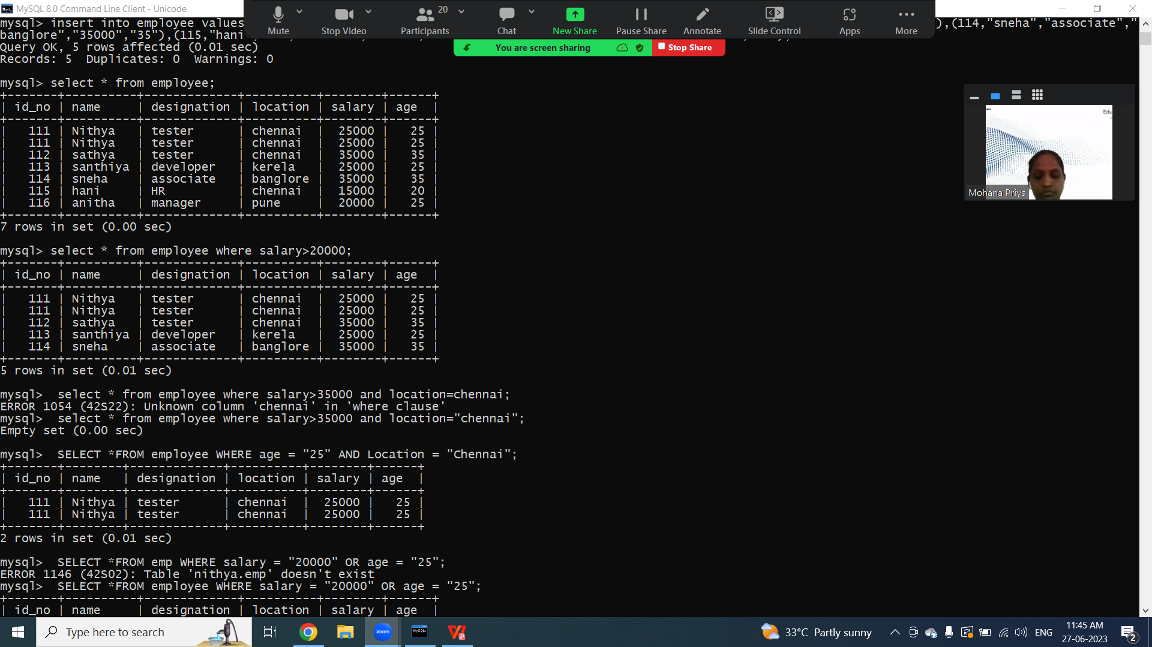

TCL COMMANDS

Enter password: *********

Welcome to the MySQL monitor. Commands end with ; or \g.

Your MySQL connection id is 11

Server version: 8.0.30 MySQL Community Server - GPL

Copyright (c) 2000, 2022, Oracle and/or its affiliates.

Oracle is a registered trademark of Oracle Corporation and/or its

affiliates. Other names may be trademarks of their respective

owners.

Type 'help;' or '\h' for help. Type '\c' to clear the current input statement.

mysql> use nithya;

Database changed

mysql> create table student(name varchar(10),subject varchar(10),marks int(5), grade varchar(5));

ERROR 1050 (42S01): Table 'student' already exists

mysql> create table student1(name varchar(10),subject varchar(10),marks int(5), grade varchar(5));

Query OK, 0 rows affected, 1 warning (0.04 sec)

mysql> insert into student values("nithya","tamil","95","A"),("hani","maths","80","b"),("sathya","tamil","90","A"),("vidhya","english","85","c");

Query OK, 4 rows affected (0.01 sec)

Records: 4 Duplicates: 0 Warnings: 0

mysql> select * from student1;

Empty set (0.00 sec)

mysql> insert into student1 values("nithya","tamil","95","A"),("hani","maths","80","b"),("sathya","tamil","90","A"),("vidhya","english","85","c");

Query OK, 4 rows affected (0.00 sec)

Records: 4 Duplicates: 0 Warnings: 0

mysql> select * from student1;

+--------+---------+-------+-------+

| name | subject | marks | grade |

+--------+---------+-------+-------+

| nithya | tamil | 95 | A |

| hani | maths | 80 | b |

| sathya | tamil | 90 | A |

| vidhya | english | 85 | c |

+--------+---------+-------+-------+

4 rows in set (0.00 sec)

mysql> START TRANSACTION;

Query OK, 0 rows affected (0.00 sec)

mysql> SAVEPOINT Insertion;

Query OK, 0 rows affected (0.00 sec)

mysql> update student set marks='200' where name = "vidhya";

Query OK, 1 row affected (0.00 sec)

Rows matched: 2 Changed: 1 Warnings: 0

mysql> update student set marks='200' where name = "vidhya";

Query OK, 0 rows affected (0.00 sec)

Rows matched: 2 Changed: 0 Warnings: 0

mysql> select * from student1;

+--------+---------+-------+-------+

| name | subject | marks | grade |

+--------+---------+-------+-------+

| nithya | tamil | 95 | A |

| hani | maths | 80 | b |

| sathya | tamil | 90 | A |

| vidhya | english | 85 | c |

+--------+---------+-------+-------+

4 rows in set (0.00 sec)

mysql> update student1 set marks='200' where name = "vidhya";

Query OK, 1 row affected (0.00 sec)

Rows matched: 1 Changed: 1 Warnings: 0

mysql> select * from student1;

+--------+---------+-------+-------+

| name | subject | marks | grade |

+--------+---------+-------+-------+

| nithya | tamil | 95 | A |

| hani | maths | 80 | b |

| sathya | tamil | 90 | A |

| vidhya | english | 200 | c |

+--------+---------+-------+-------+

4 rows in set (0.00 sec)

mysql> SAVEPOINT Updation;

Query OK, 0 rows affected (0.00 sec)

mysql> ROLLBACK TO Insertion;

Query OK, 0 rows affected (0.00 sec)

mysql> select * from student1;

+--------+---------+-------+-------+

| name | subject | marks | grade |

+--------+---------+-------+-------+

| nithya | tamil | 95 | A |

| hani | maths | 80 | b |

| sathya | tamil | 90 | A |

| vidhya | english | 85 | c |

+--------+---------+-------+-------+

4 rows in set (0.00 sec)

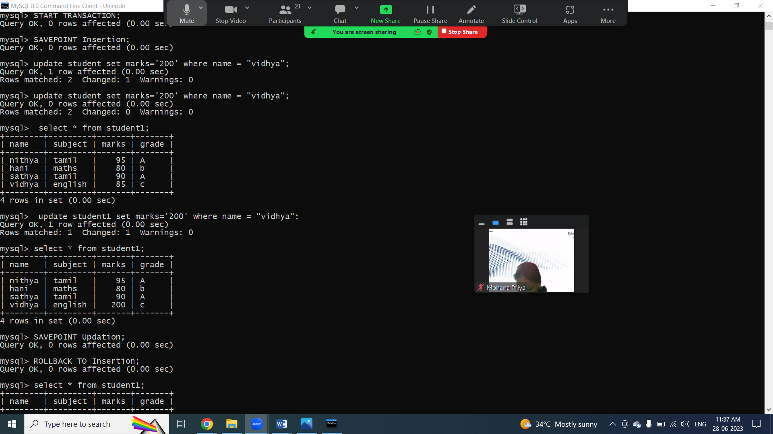

JOINS IN SQL

Enter password: *********

Welcome to the MySQL monitor. Commands end with ; or \g.

Your MySQL connection id is 12

Server version: 8.0.30 MySQL Community Server - GPL

Copyright (c) 2000, 2022, Oracle and/or its affiliates.

Oracle is a registered trademark of Oracle Corporation and/or its

affiliates. Other names may be trademarks of their respective

owners.

Type 'help;' or '\h' for help. Type '\c' to clear the current input statement.

mysql> use nithya;

Database changed

mysql> create table student(roll_no int(5),admin_no varchar(10),first name varchar(15),last name varchar (15),age int);

ERROR 1064 (42000): You have an error in your SQL syntax; check the manual that corresponds to your MySQL server version for the right syntax to use near 'name varchar(15),last name varchar (15),age int)' at line 1

mysql> create table student(roll_no int(5),admin_no varchar(10),first_name varchar(15),last_name varchar (15),age int(5));

ERROR 1050 (42S01): Table 'student' already exists

mysql> create table student1(roll_no int(5),admin_no varchar(10),first_name varchar(15),last_name varchar (15),age int(5));

ERROR 1050 (42S01): Table 'student1' already exists

mysql> create table stu(roll_no int(5),admin_no varchar(10),first_name varchar(15),last_name varchar (15),age int(5));

Query OK, 0 rows affected, 2 warnings (0.07 sec)

mysql> create table fee(admin_no varchar(10),course varchar(15),amount int (10));

Query OK, 0 rows affected, 1 warning (0.03 sec)

mysql> insert into stu values(1,2234,"nithya","m",15,"chennai"),(2,4434,"nivya","p",21,"pondi"),(2,5234,"hani","g",20,"guindy"),(4,4234,"sneha","t",18,"tambaram"),(5,2222,"vidya","w",17,"padur"),(6,2334,"sathya","s",16,"adyar");

ERROR 1136 (21S01): Column count doesn't match value count at row 1

mysql> insert into stu values(1,2234,"nithya","m",15),(2,4434,"nivya","p",21),(2,5234,"hani","g",20),(4,4234,"sneha","t",18),(5,2222,"vidya","w",17),(6,2334,"sathya","s",16);

Query OK, 6 rows affected (0.01 sec)

Records: 6 Duplicates: 0 Warnings: 0

mysql> insert into fee values(4434,"java",2000),(5234,"sql",3000),(2222,"html",4000);

Query OK, 3 rows affected (0.01 sec)

Records: 3 Duplicates: 0 Warnings: 0

mysql> select * from stu;

+---------+----------+------------+-----------+------+

| roll_no | admin_no | first_name | last_name | age |

+---------+----------+------------+-----------+------+

| 1 | 2234 | nithya | m | 15 |

| 2 | 4434 | nivya | p | 21 |

| 2 | 5234 | hani | g | 20 |

| 4 | 4234 | sneha | t | 18 |

| 5 | 2222 | vidya | w | 17 |

| 6 | 2334 | sathya | s | 16 |

+---------+----------+------------+-----------+------+

6 rows in set (0.01 sec)

mysql> select * from fee;

+----------+--------+--------+

| admin_no | course | amount |

+----------+--------+--------+

| 4434 | java | 2000 |

| 5234 | sql | 3000 |

| 2222 | html | 4000 |

+----------+--------+--------+

3 rows in set (0.00 sec)

mysql> SELECT Stu.admin_no, Stu.first_name, Stu.last_name, Fee.course, Fee.amount FROM StuINNER JOIN Fee ON Stu.admin_no = Fee.admin_no;

ERROR 1146 (42S02): Table 'nithya.stuinner' doesn't exist

mysql> SELECT Stu.admin_no, Stu.first_name, Stu.last_name, Fee.course, Fee.amount FROM Stu INNER JOIN Fee ON Stu.admin_no = Fee.admin_no;

+----------+------------+-----------+--------+--------+

| admin_no | first_name | last_name | course | amount |

+----------+------------+-----------+--------+--------+

| 4434 | nivya | p | java | 2000 |

| 5234 | hani | g | sql | 3000 |

| 2222 | vidya | w | html | 4000 |

+----------+------------+-----------+--------+--------+

3 rows in set (0.00 sec)

mysql> SELECT Stu.admin_no, Stu.first_name, Stu.last_name, Fee.course, Fee.amount FROM Stu left outer JOIN Fee ON Stu.admin_no = Fee.admin_no;

+----------+------------+-----------+--------+--------+

| admin_no | first_name | last_name | course | amount |

+----------+------------+-----------+--------+--------+

| 2234 | nithya | m | NULL | NULL |

| 4434 | nivya | p | java | 2000 |

| 5234 | hani | g | sql | 3000 |

| 4234 | sneha | t | NULL | NULL |

| 2222 | vidya | w | html | 4000 |

| 2334 | sathya | s | NULL | NULL |

+----------+------------+-----------+--------+--------+

6 rows in set (0.00 sec)

mysql> SELECT Stu.admin_no, Stu.first_name, Stu.last_name, Fee.course, Fee.amount FROM Stu right outer JOIN Fee ON Stu.admin_no = Fee.admin_no;

+----------+------------+-----------+--------+--------+

| admin_no | first_name | last_name | course | amount |

+----------+------------+-----------+--------+--------+

| 4434 | nivya | p | java | 2000 |

| 5234 | hani | g | sql | 3000 |

| 2222 | vidya | w | html | 4000 |

+----------+------------+-----------+--------+--------+

3 rows in set (0.00 sec)

mysql> SELECT Stu.admin_no, Stu.first_name, Stu.last_name, Fee.course, Fee.amount FROM Stu full outer JOIN Fee ON Stu.admin_no = Fee.admin_no;

ERROR 1064 (42000): You have an error in your SQL syntax; check the manual that corresponds to your MySQL server version for the right syntax to use near 'outer JOIN Fee ON Stu.admin_no = Fee.admin_no' at line 1

mysql> SELECT Stu.admin_no, Stu.first_name, Stu.last_name, Fee.course, Fee.amount FROM Stu CROSS JOIN Fee WHERE Stu.admin_no = Fee.admin_no;

+----------+------------+-----------+--------+--------+

| admin_no | first_name | last_name | course | amount |

+----------+------------+-----------+--------+--------+

| 4434 | nivya | p | java | 2000 |

| 5234 | hani | g | sql | 3000 |

| 2222 | vidya | w | html | 4000 |

+----------+------------+-----------+--------+--------+

3 rows in set (0.01 sec)

mysql> SELECT Stu.admin_no, Stu.first_name, Fee.course, Fee.amount FROM Stu CROSS JOIN Fee WHERE Stu.admin_no = Fee.admin_no;

+----------+------------+--------+--------+

| admin_no | first_name | course | amount |

+----------+------------+--------+--------+

| 4434 | nivya | java | 2000 |

| 5234 | hani | sql | 3000 |

| 2222 | vidya | html | 4000 |

+----------+------------+--------+--------+

3 rows in set (0.00 sec)

mysql> SELECT Stu.admin_no, Stu.first_name, Fee.course, Fee.amount FROM stu , Fee WHERE Stu.admin_no < Fee.admin_no order by stu.admin_no;

+----------+------------+--------+--------+

| admin_no | first_name | course | amount |

+----------+------------+--------+--------+

| 2222 | vidya | sql | 3000 |

| 2222 | vidya | java | 2000 |

| 2234 | nithya | sql | 3000 |

| 2234 | nithya | java | 2000 |

| 2334 | sathya | sql | 3000 |

| 2334 | sathya | java | 2000 |

| 4234 | sneha | sql | 3000 |

| 4234 | sneha | java | 2000 |

| 4434 | nivya | sql | 3000 |

+----------+------------+--------+--------+

9 rows in set (0.01 sec)

mysql> SELECT Stu.admin_no, Stu.first_name, Fee.course, Fee.amount FROM stu , Fee WHERE Stu.admin_no < Fee.admin_no;

+----------+------------+--------+--------+

| admin_no | first_name | course | amount |

+----------+------------+--------+--------+

| 2234 | nithya | sql | 3000 |

| 2234 | nithya | java | 2000 |

| 4434 | nivya | sql | 3000 |

| 4234 | sneha | sql | 3000 |

| 4234 | sneha | java | 2000 |

| 2222 | vidya | sql | 3000 |

| 2222 | vidya | java | 2000 |

| 2334 | sathya | sql | 3000 |

| 2334 | sathya | java | 2000 |

+----------+------------+--------+--------+

9 rows in set (0.00 sec)

